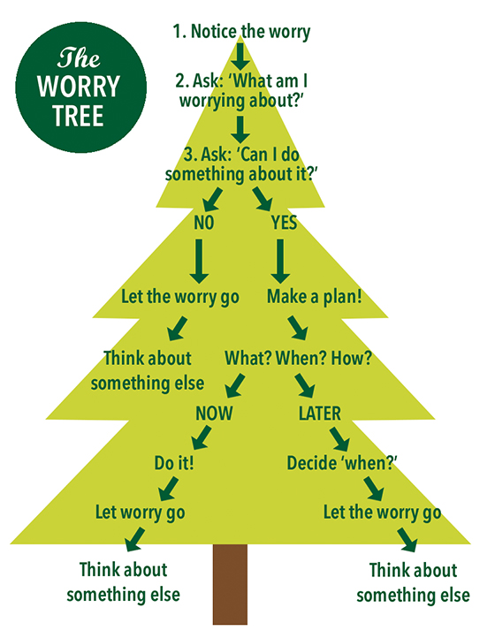

Instructions- Print out the tree and use as a visual
The Worry Decision Tree can be used to help children understand and manage their worries by following the steps of the flow diagram:
- The initial step is to notice that worry is occurring.
- The next step is to identify whether this is a real event worry about which something can be done, or whether the worry concerns a hypothetical future event about which it is not possible to act.
- If action is possible, it must be determined whether this can happen immediately (in which case it is to be actioned immediately), or whether it can happen at some time in the future in which case specific plans are made before the worry is set aside and attention focused elsewhere.
- If the worry is hypothetical and action is not possible, then the worry is to be set aside and attention focused elsewhere. Children may find it helpful to engage in worry postponement as a behavioural experiment, or to practice reorienting techniques such as mindful awareness.

How to make a worry box
Children will feel more in control (and have fun) if they are the ones to make their own container to hold their worries. You can make a worry box out of any kind of container, such as a tissue box, a chip container, or a tin can.

How to use a worry box
The worry box is ideal for a range of age groups. After the box is made, show your child how to use it. Tell them that when a worry pops up, they can write down or draw the worry and put it into the box. If necessary, you can write the worry for them, but you shouldn’t get into a big discussion about the worry at that time. The idea is that the child is learning to contain their worry with very little adult help. If your child prefers to fold or scrunch the paper before putting it the box, that is fine. The important part is that the worry is being released from the child into a container. Tell your child that the worry can be big or small and any number of worries can be put in at a time.

Combining the worry box with worry time & the worry tree
Schedule worry time each day for one/two days a week. Put it in your calendar. Start by setting aside 15-30 minutes during the morning or afternoon. That will be your worry time. It’s best not to schedule worry time right before bed.
Should you look at what your child writes? Technically, no. The box is meant to be a safe place where the child can write down anything and not have it “discovered.” Instead, you could set up a worry time when your child can discuss their worries with you.
Worry time is also a form of containment because it restricts the time the child can dwell on their worries with an adult. You can set up the time specially for the child, say from 4:00 to 4:20 every afternoon. If at 4:20 your child is not through discussing their worries, ask them to write down the worries and put them into the worry box. Tell them that they can take them out to discuss tomorrow at the same time.
The worries are now manageable, safely held and will not take over all the day and night. They are contained in both time (worry time) and space (worry box).
If there are times when your child does not want to do worry time, that is ok!

